**Simulation results.**

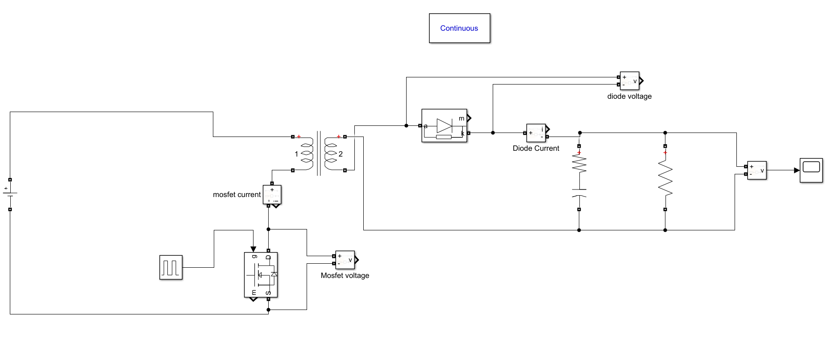

Figure xX: Circuit diagram of the project.

1. **Output voltage verification.**

In order to observer how much the duty cycle is deviated from the ideal case to compansate non linearities.

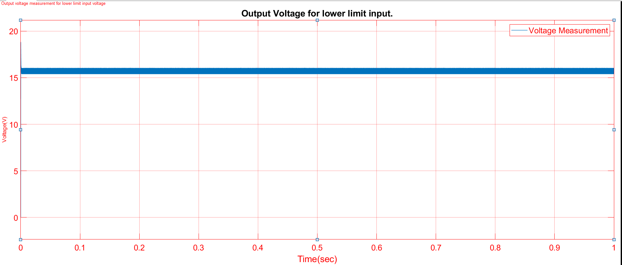

FigureXX: Output voltage verification.

1. **Diode ratings**

* This simulation is done such that the duty cycle is the value that creates most voltage stress on the diode and also highest current.

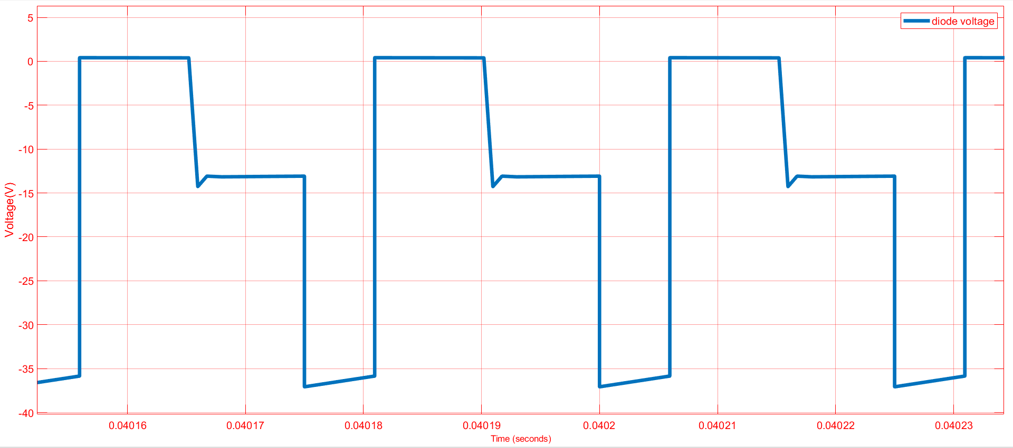

FigureXX: Voltage stress on the diode.

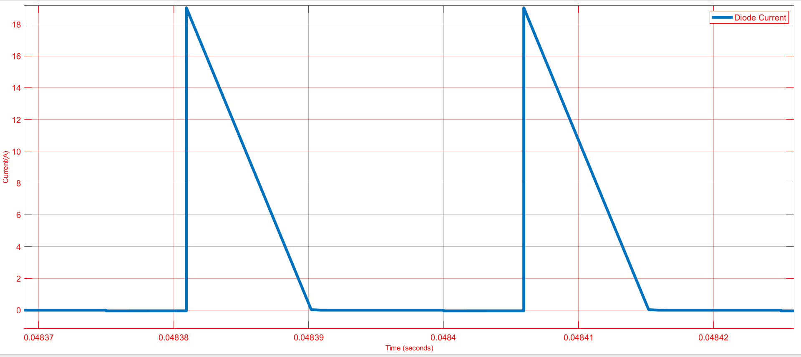

FigureXX: Current stress on the diode.

1. **Mosfet ratings.**

* This simulation has been done under the conditions where the mosfet current and voltage at its highest value.

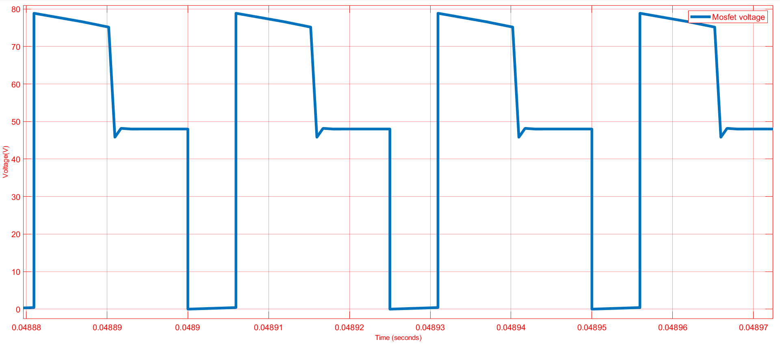

FigureXX: Voltage stress on the mosfet.

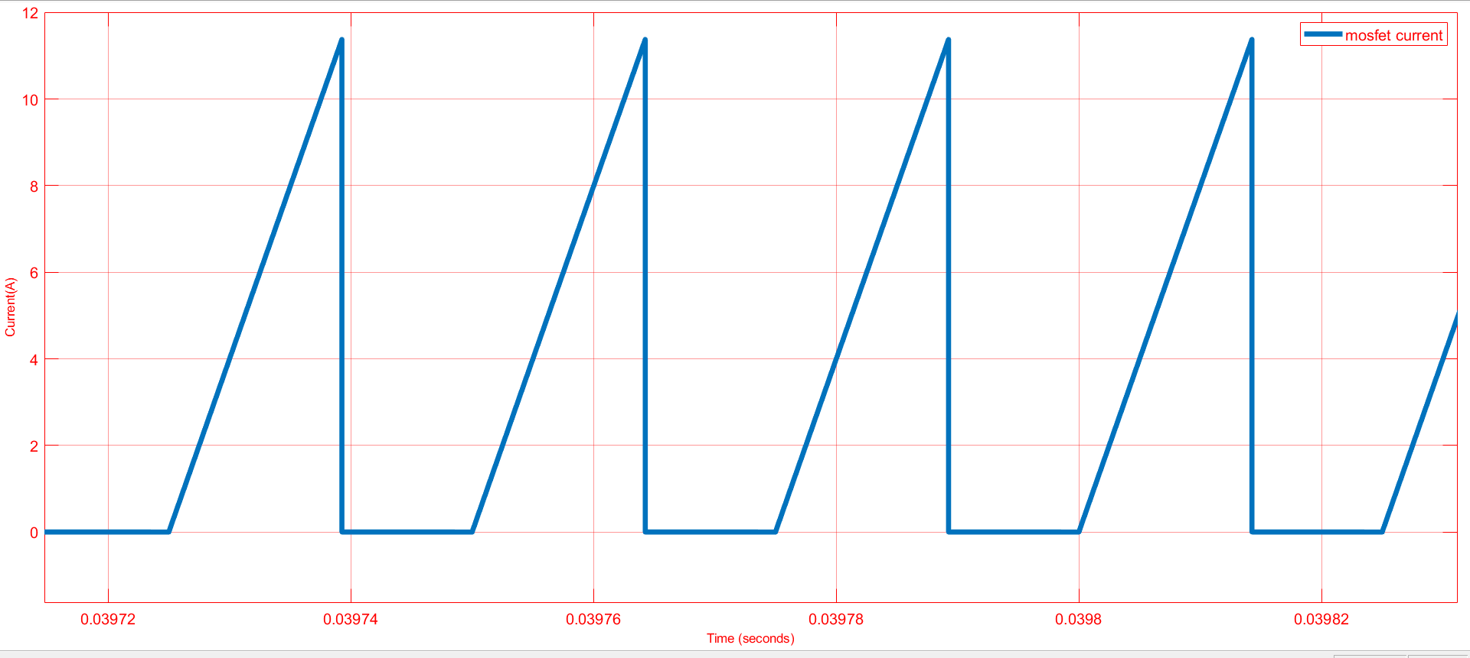

FigureXX:Current stress on the mosfet.

1. **Output ripple.**

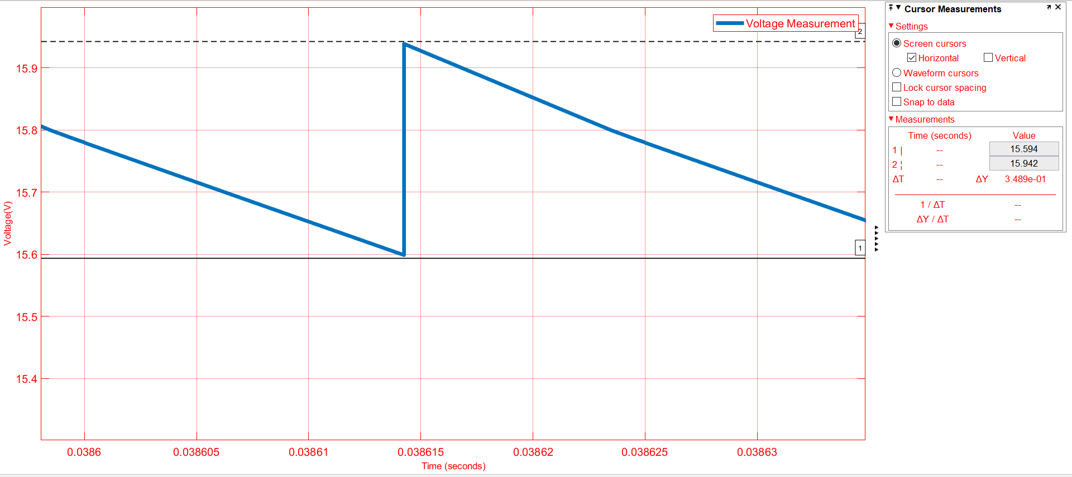

FigureXX: Output ripple.

* Output voltage ripple is approximately %2.5 according to the simulation result.

1. **Snubber**

* Snubber is designed not to exceed our mosfet voltage limit and also providing enough time to dissipate the energy on the leakage inductances.

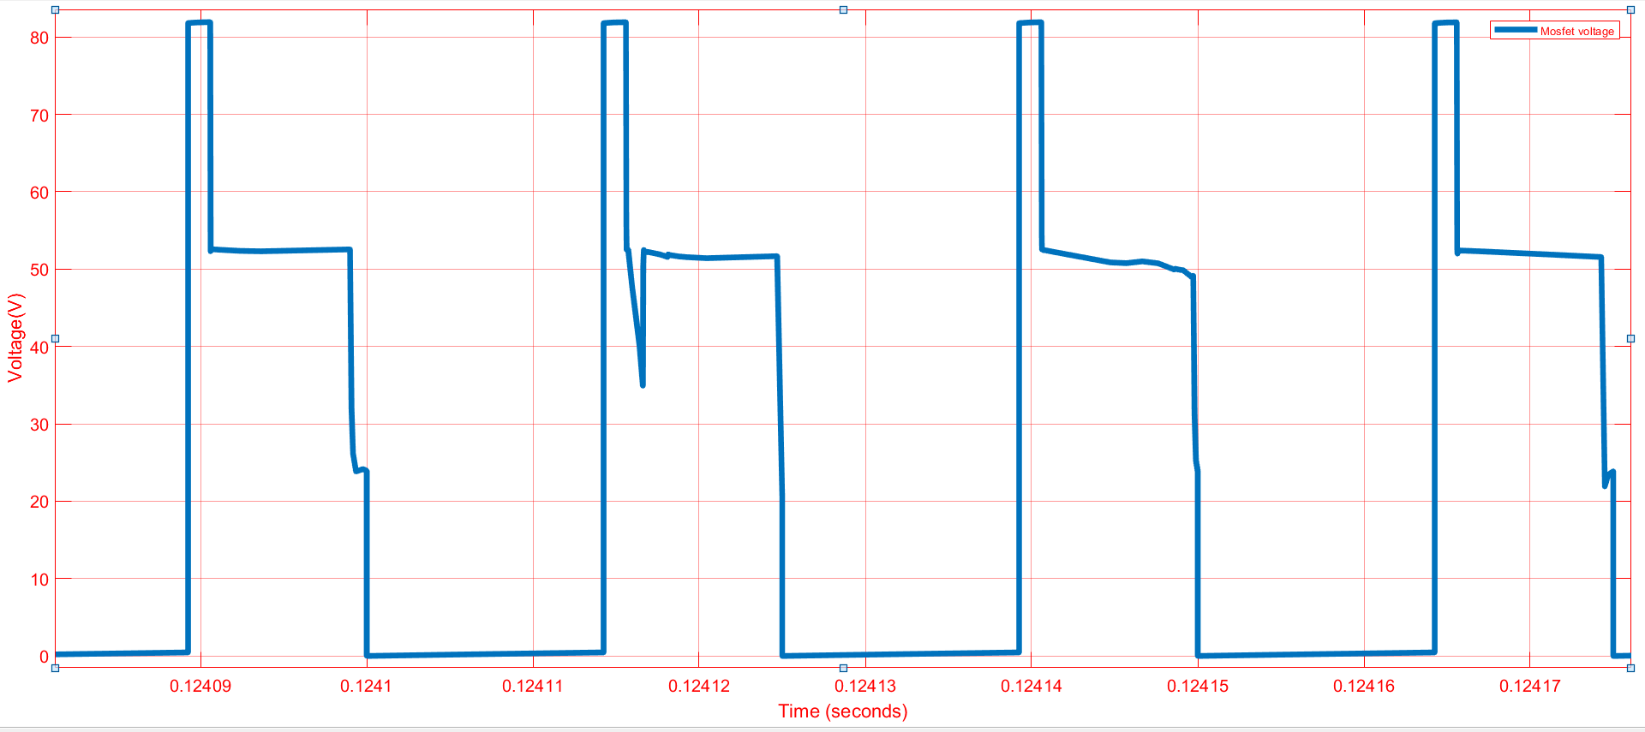

FigureXX: Voltage stress on the mosfet with snubber.